## Notes on performing an End-to-end Demo using the Nazare Environment (nlopez)

Refer to the pre-setup and screen shot sections below.

**Demo Steps**

1. Logon to IDz and connect to TIVLP02.SVL.IBM.COM (the Naz Box)
2. In Git perspective (Cloning & Branching) - Naz Repo <https://github.ibm.com/IBMZSoftware/nazare-demo-genapp>
   1. Explain eGit Cloning of Git Hub Repo - [git@github.ibm.com:IBMZSoftware/nazare-demo-genapp.git](mailto:git@github.ibm.com:IBMZSoftware/nazare-demo-genapp.git)
   2. Explain how to create a branch and why
   3. Pull from master to refresh your local repo
3. zOS perspective (Edit Code and run a DBB User Build)
   1. Edit pgm **LGIPOL01.**  For example, change the comment
   2. save the change
   3. Do a DBB User Build and show the sysprint
4. Git Perspective (commit and push to Git)
   1. In the Git staging window, add “+” the chg’d pgm and commit/push with a message
5. In Git Hub – the Naz. Repo
   1. Select you your branch and create a Pull Request for the **“**[**IBMZSoftware**](https://github.ibm.com/IBMZSoftware)**/**[**nazare-demo-genapp**](https://github.ibm.com/IBMZSoftware/nazare-demo-genapp)**“** repo NOT the repo starting with “Ian…”. The PR will have a number which is useful for tracking in Jenkins later.
6. As a Repo approver on another browser– approve your PR to start Jenkins
7. Back to your Git Hub PR, refresh the page to confirm the request is approved. When Jenkins completes, all the other steps will be marked completed.
8. In Jenkins <http://zdevops-demo.rtp.raleigh.ibm.com:8080/> (admin/think2019)
   1. Go to the main dashboard page “the Jenkins link top left” and select **“GenAppNazarePipeline”**. Then select the “Pull requests” tab. Your PR # should be running or completed.
   2. Select your PR # to show the pipeline steps. Click in the green box of a step to show the log.
   3. Note: The Deploy step is not UCD, it’s a set of groovy scripts to copy the load module to the CICS PDS.
9. Back to your PR in Git Hub
   1. Review that all steps ended “green check mark”
   2. Press Merge pull request and then Attempt to merge.
   3. This closes the PR and starts a final Jenkins integration Build (Merged status)
10. In Jenkins
    1. Track progress from the Branches tab where you can select “master”.
    2. Then select the “Open Blue Ocean” item to view the job’s progress graphically.

## Pre Set-Up

1. Request access to Nazare zOS TIVLP02.SVL.IBM.COM and define the remote host in IDz.
2. In IDz clone [git@github.ibm.com:IBMZSoftware/nazare-demo-genapp.git](mailto:git@github.ibm.com:IBMZSoftware/nazare-demo-genapp.git)
3. Make a local branch for demo’g. Some suggest creating and deleting it in the demo. I just reuse the same one to avoid issues. You can explain how to clone and create a branch.
4. Before your demo PULL from master to refresh your local copy (see below)
5. Pre set-up and test your DBB User Build (see screens below)
6. Before the demo have one of the Naz. Repo Approvers ready to approve your P – Like Nicolas or Suman. Or asked them to pre-logon to Git Hub under another browser on your PC (I use edge for my work and chrome for the approver).
7. Run the demo a few times to get the timing right, the Naz. host is zDT and slow.

Screens

**Pull from Master to re-fresh your local clone and avoid merge conflicts**

Use the first pull option

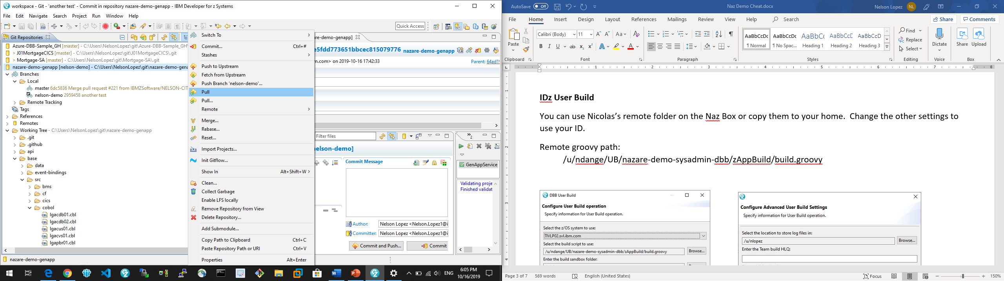

**IDz User Build**

You can use Nicolas’s remote folder on the Naz Box or copy them to your home. Change the other settings to use your ID. Remote groovy path = /u/ndange/UB/nazare-demo-sysadmin-dbb/zAppBuild/build.groovy

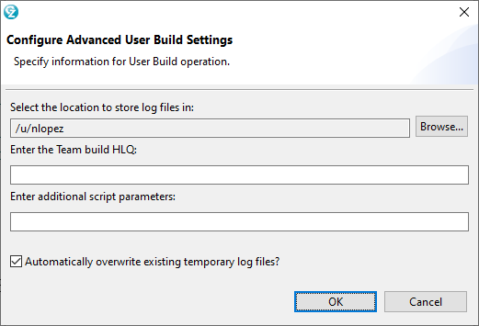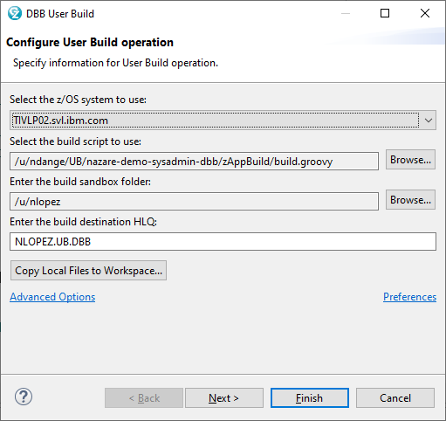

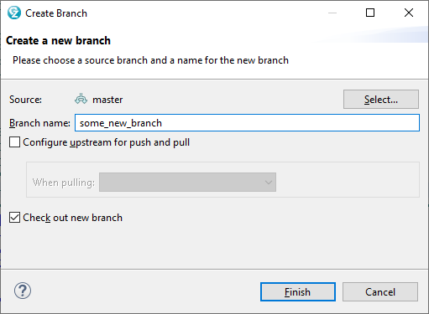**Create a New Branch (right click on master in git perspective)**Do this once a reuse it for your future demos.

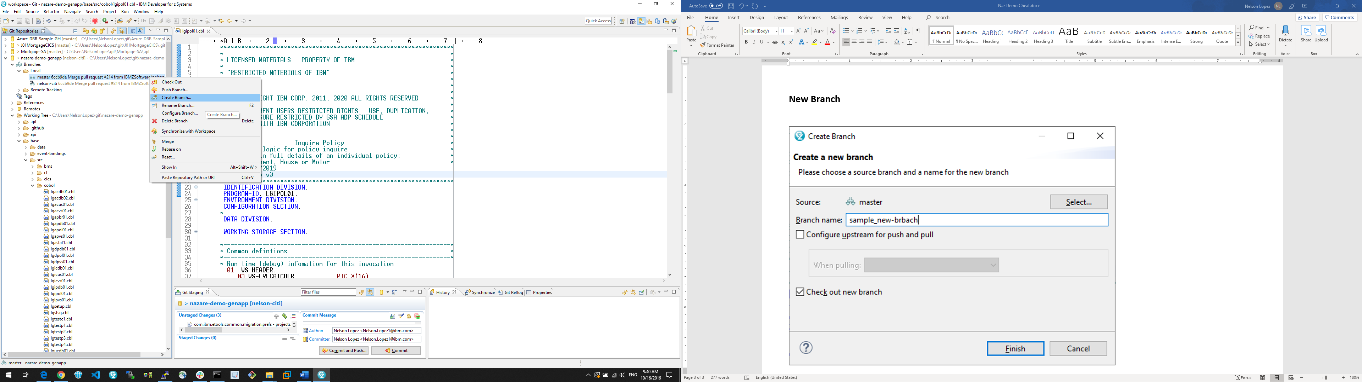

**eGit Local Commit Branch and Push to Git Hub**

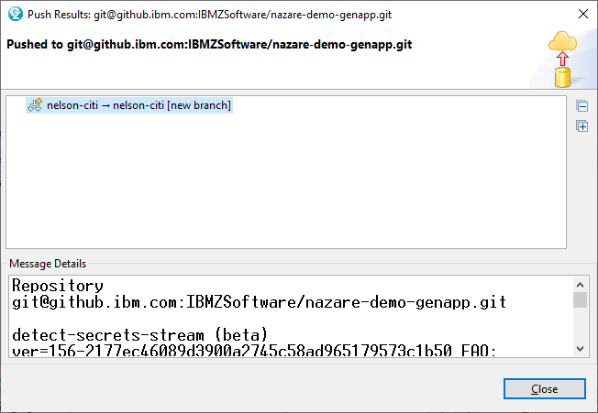After saving your source code changes in the zOS prepective, jump to the git prespective and in the Git staging window, select the program name in the “unstaged” pane then press the single + to move it to the “staged” pane. Add an commit message and press commit and push to save it locally and in to Git Hub.

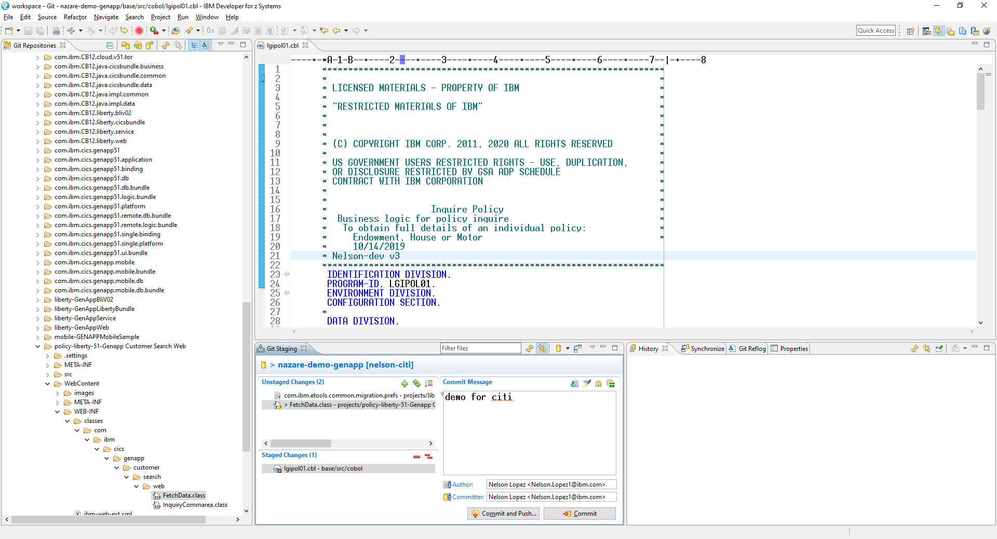

**Create the PULL Request – BE CAREFULL HERE !!!!**

Go to[**https://github.ibm.com/IBMZSoftware/nazare-demo-genapp**](https://github.ibm.com/IBMZSoftware/nazare-demo-genapp)

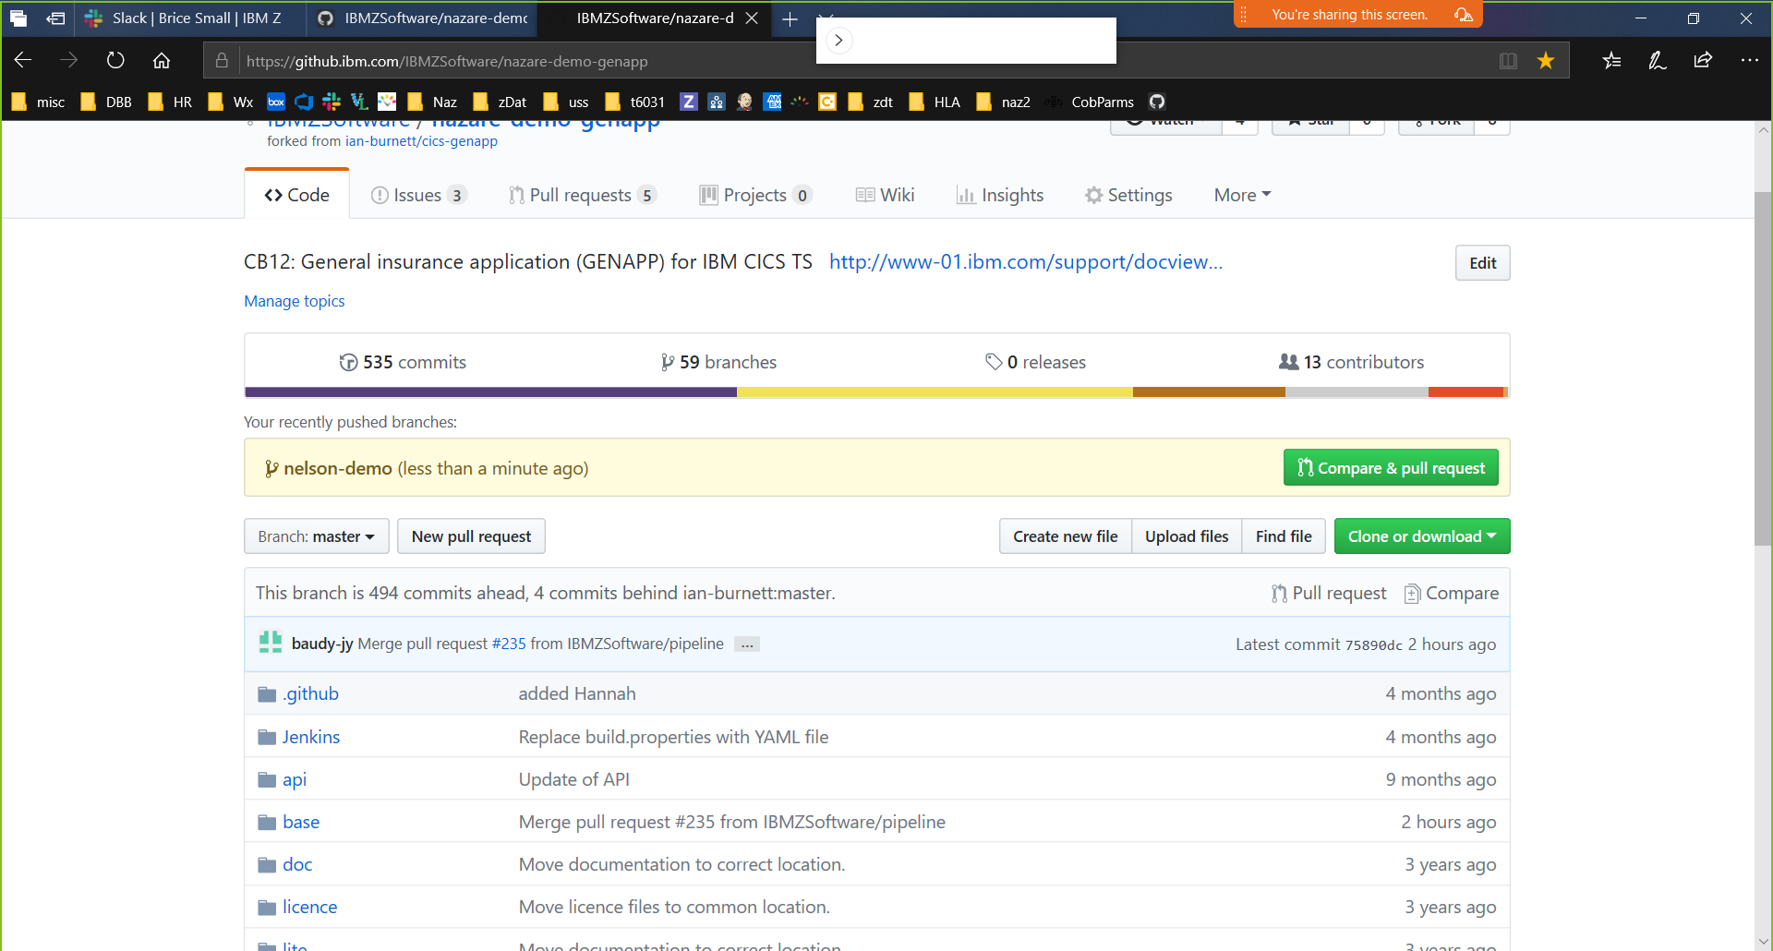From the main page select your pushed branch should appear on the Naz Repo home page. Select Compare & Pull Request to submit a PR. Or go to the branches tab and search for your branch.

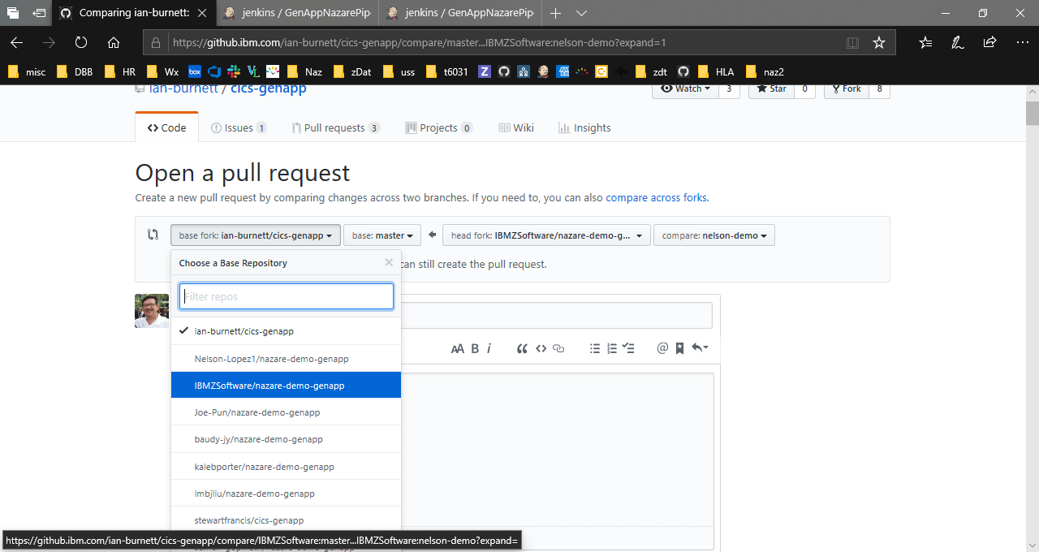**FYI WARNING – On the next screen** *change the base fork repo name to* [*IBMZSoftware*](https://github.ibm.com/IBMZSoftware)*/*[*nazare-demo-genapp*](https://github.ibm.com/IBMZSoftware/nazare-demo-genapp)Then select create pull request on bottom of the page. The request is now open and ready for approval.

**PR Approver Screen**

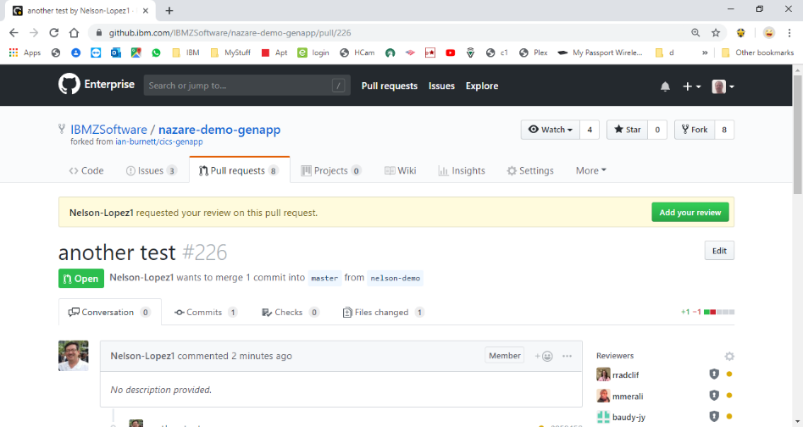The approver (some one other than you) goes to the same repo in git hub and selects Pull Requests. Then, add your review.

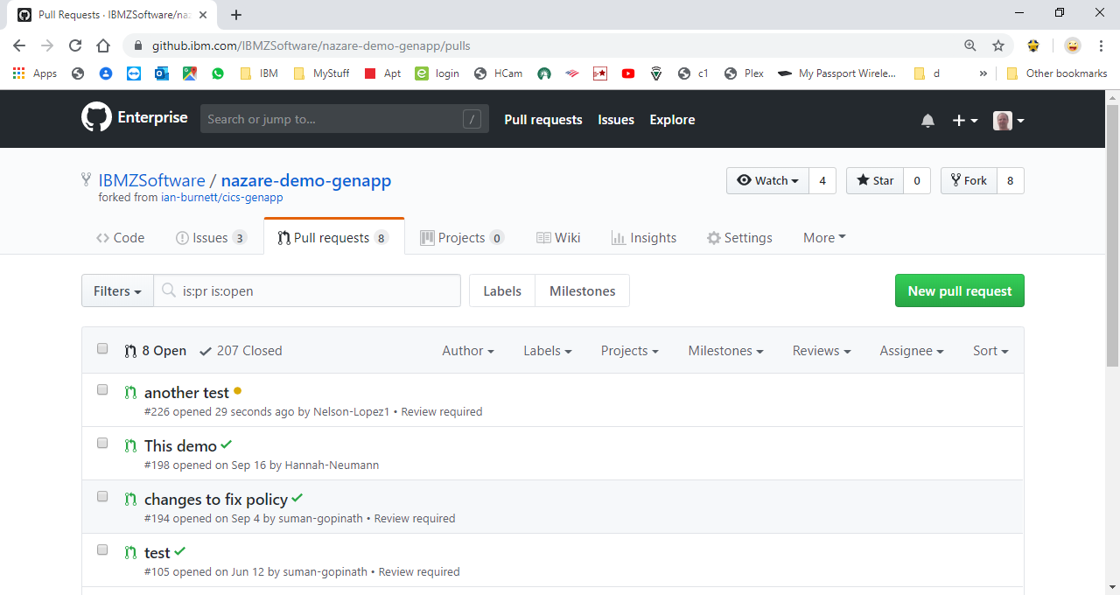

Finally, select the Approve radio button and submit

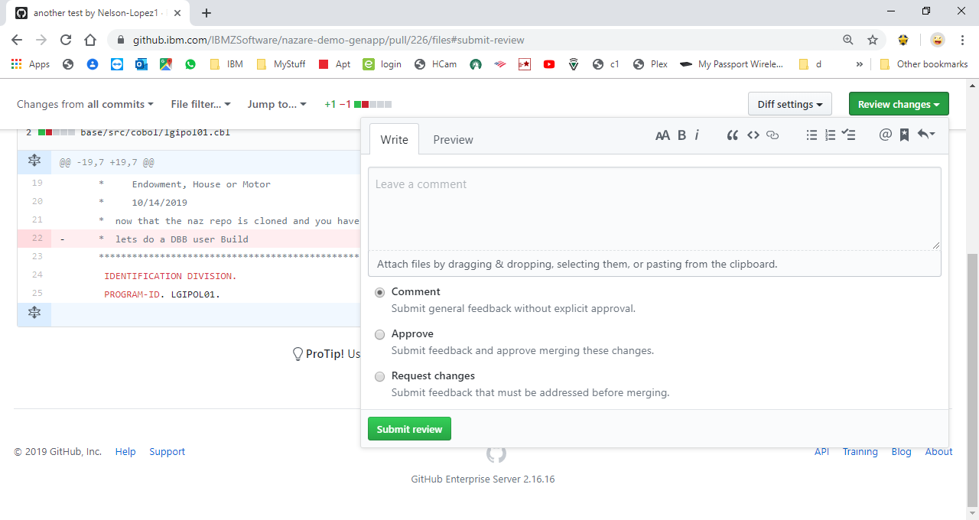

**Jenkins**

[**http://zdevops-demo.rtp.raleigh.ibm.com:8080/**](http://zdevops-demo.rtp.raleigh.ibm.com:8080/)

Start from the main Jenkins home page, select the GenApp… job and then the Pull Request tab

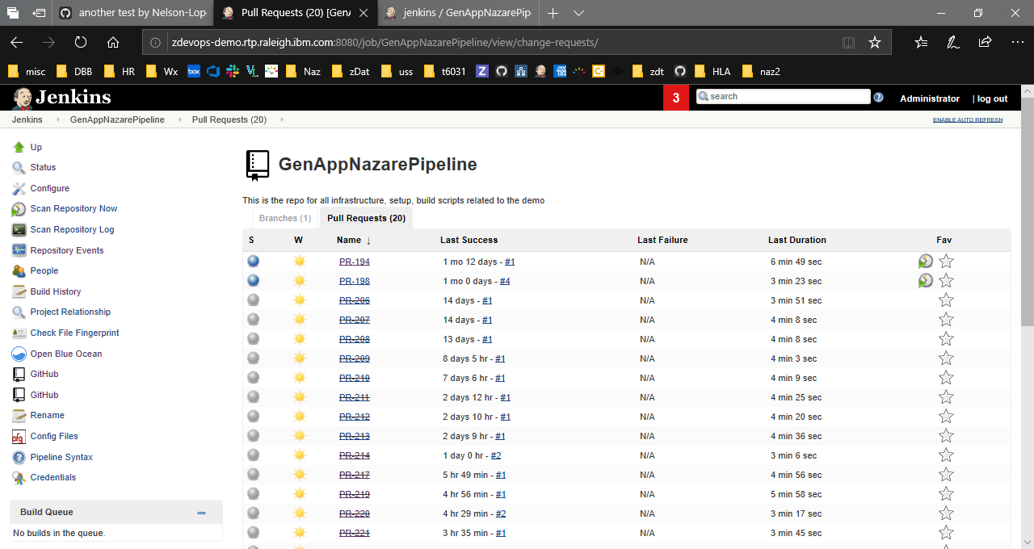

Click on a step to view the log

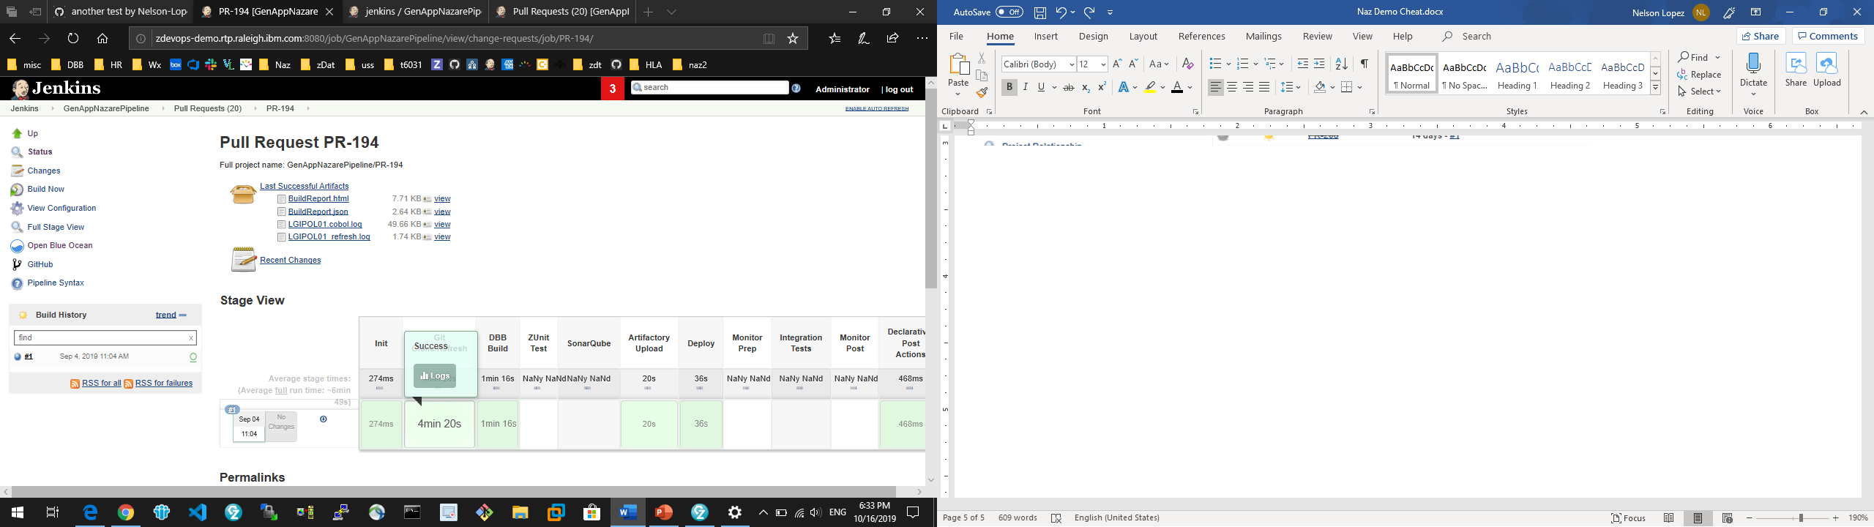

The deploy log showing groovy scripts (non-ucd)

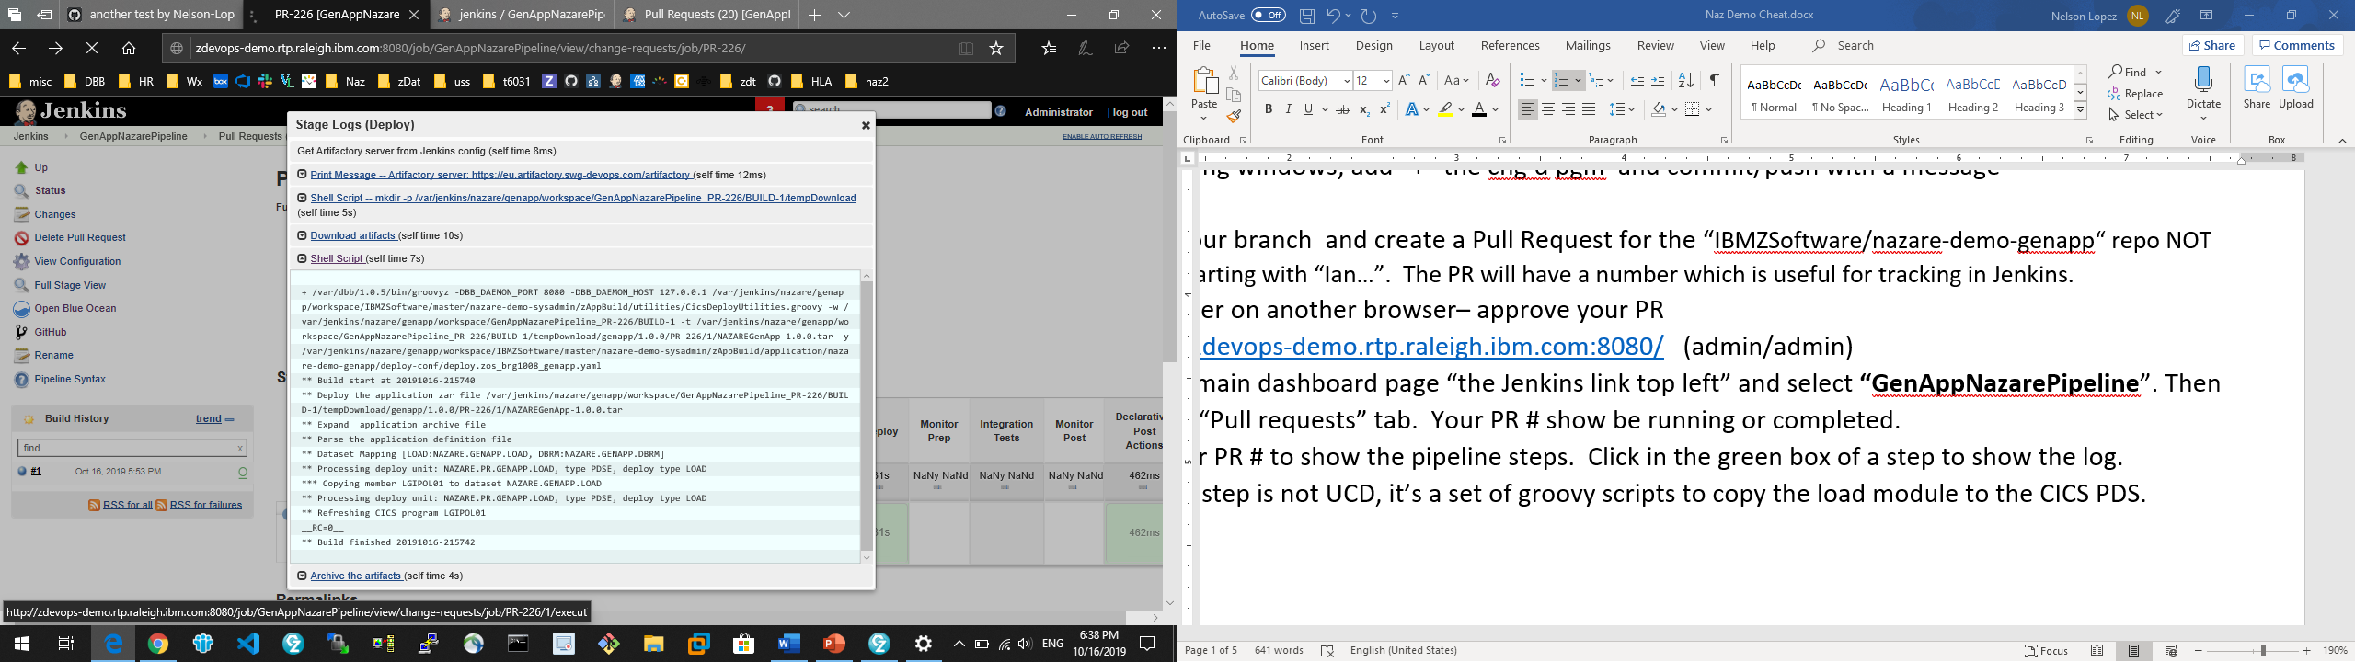

**You’re Done!**